Introduction
The team was tasked to develop a machine learning model that can accurately classify a photo by who the photographer is. For this task, two sets of image datasets, images taken by Kelly Bodwin and Alex Dekhytar, were provided to the team. Given this resource, the team hopes to use these images to train a model that is capable of accurately classifying the images by photographer.

Modeling Procedure
Models
We were curious of the effect of model architecture on the accuracy of the predictions, so we wanted to test three neural networks:

- ResNet-50
  - A pre-trained model that is highly known for its ability to capture complex patterns, making it a powerful tool for image classification. The model has been pre-trained on massive datasets, allowing it to better capture the subtle and complex patterns in new images.

- MobileNetV2
  - A lightweight CNN architecture made to be quick and efficient, which makes it ideal for deployment in settings with limited resources. The model maintains excellent accuracy while lowering computational requirements by utilizing novel strategies like linear bottlenecks and inverted residuals. Large-scale datasets have been used to pre-train MobileNetV2, which allows it to efficiently extract pertinent features and manage challenging image classification tasks.

- Custom Convolutional Neural Network with Attention
  - It's an attention-integrated, customized CNN for highlighting the main features through channel-wise attention. The network starts with typical convolutional layers that adopt efficient mechanisms of depthwise separable convolutions and skip connections for capturing both spatial and feature-related patterns efficiently. An embedded attention module performs a summary of feature maps by using global average pooling, followed by fully connected layers that compute the attention weights; these are used for the final reweighting of feature maps. This allows the network to dynamically highlight the most relevant information in every image.

  - While this custom architecture is simpler compared to many pre-trained models, it is lightweight and agile, hence more suitable for data-limited applications. Using attention mechanisms, it focuses on the most informative features, thereby overcoming the challenge brought forth by small datasets with great efficiency. It was, in fact, this focus on critical patterns that made it perform better when combined with handcrafted feature extraction methods.

It’s important to keep in mind that we are severely limited by the amount of training images we have available to us. Since we don’t have much data, it is likely that our models will overtrain extremely quickly and find features that aren’t actually related to which photographer took the photo.

Data Preparation
After processing the images from the two directories, the dataset was read in and converted to an RGB format represented in numpy arrays, also cropping the image to 224x224 to feed into our neural networks.

To potentially improve model performance, additional features were also introduced. We thought that to help the model decide which photographer took which photo, adding extra information would be able to help the model choose. To do this, we decided on picking 5 content-related features as well as 5 composition-related features. This was done through manual inspection of each image and looking for features that may uniquely identify each photographer and their style of photos. We labeled each of the photos according to the selected features:

- Old Photo: Yes = 1, No = 0
- More Than 1 Person: Yes = 1, No = 0
- Saturation: High = 1, Low = 0
- Shadows: High = 1, Low = 0
- Nature Photo: Yes = 1, No = 0
- Blurry: Yes = 1, No = 0
- Castle: Yes = 1, No = 0
- Desert: Yes = 1, No = 0
- Has Filter: Yes = 1, No = 0
- Taken in Europe: Yes = 1, No = 0
- Rectilinear Photo (image is parallel/perpendicular to frame): Yes = 1, No = 0

Most of the features displayed a noticeable distinction between Alex and Kelly’s photos.

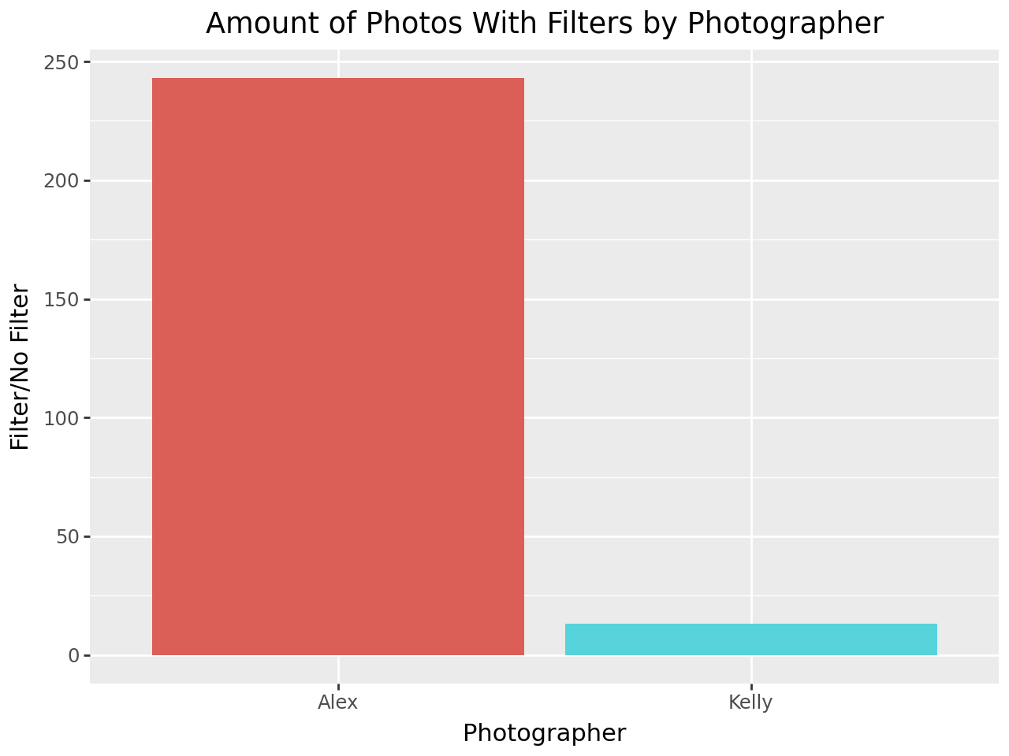
Figure 1: The proportion of photos that look like they have a filter is
much higher on Dr. Dekhtyar’s photos

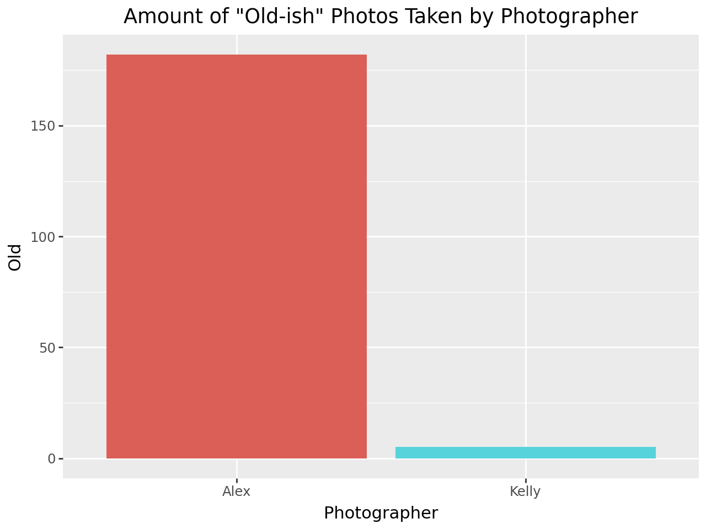
Figure 2: The proportion of photos that look like they were taken long ago is
much higher on Dr. Dekhtyar’s photos

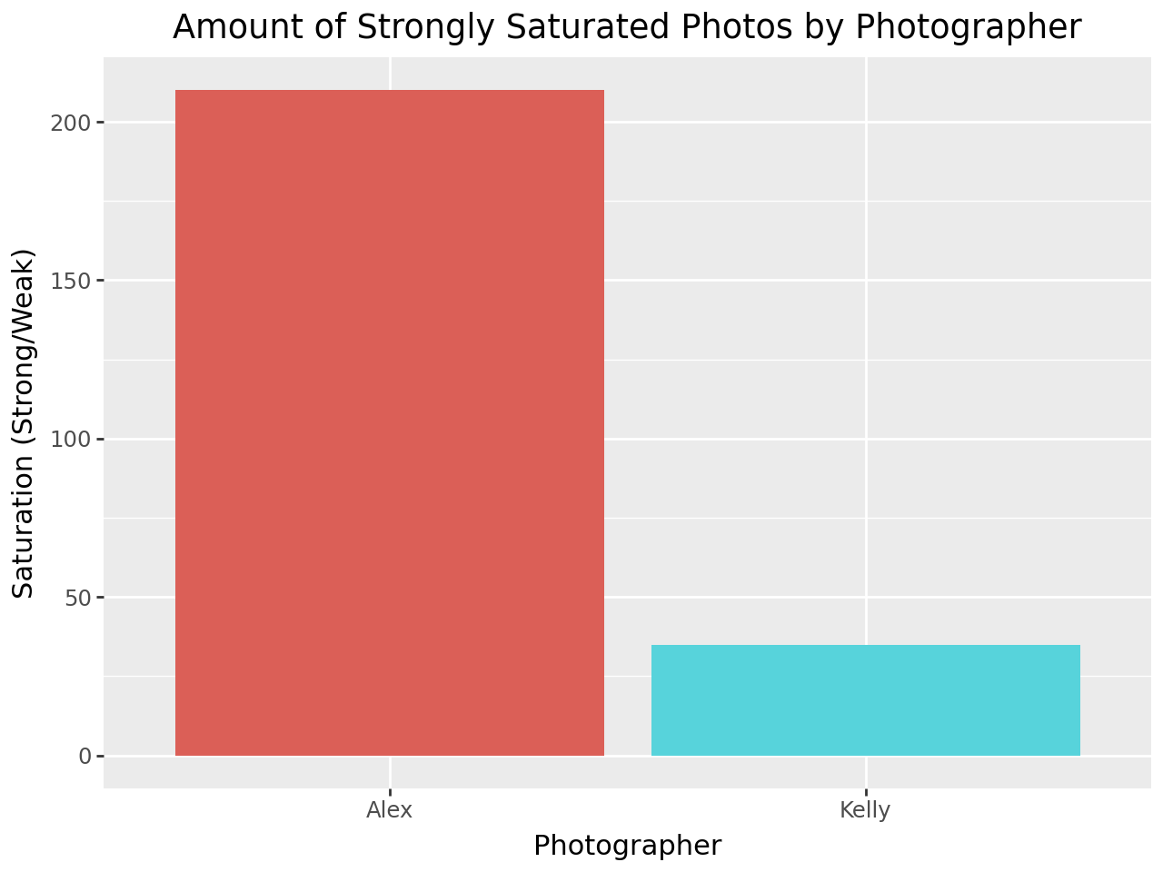

Figure 3: A significant portion of Dr. Bodwin’s photos are not seen as highly saturated

Modeling
The models were initially trained on Alex and Kelly’s images on their own, followed by their images with the additional features. A separate ensemble model was created to combine the probability output of the neural network model as well as the manual features selected for each photo. This new dataset was trained using Logistic Regression in order to predict the final prediction for each photo.

Results
Initial (ResNet)
When the ResNet-50 model was trained on the images alone, leveraging the pre-trained model’s feature extraction capabilities, the validation set achieved an impressive average accuracy of 81.82% across all five folds. This suggests that even without fine-tuning the pre-trained model, it was already able to classify the images accurately. By just training the multi-layer perceptron layers after the pre-trained output, we are still able to get a relatively good accuracy score.

Initial (MobileNetV2)
When the MobileNet was trained on the images, we obtained an accuracy of 67.76%. This outcome demonstrates the model’s ability to categorize the photos using the attributes that the pre-trained MobileNetV2 layers and the extra dense layers were able to extract. This accuracy indicates that there is potential for improvement, though it is a sign of respectable performance.
With its weights frozen during training to preserve the general-purpose feature representations it acquired on a larger dataset (like ImageNet), the pre-trained MobileNetV2 model was mostly utilized as a feature extractor. These attributes were subsequently adapted to the particular classification job by training the additional fully linked layers.

Initial (Custom CNN w/Attention)
This attention-based CNN, which was trained only on the provided image dataset, achieved an average of 47.32% accuracy over five folds. The relatively modest performance underlines inherent difficulties in designing and training a custom architecture while using limited data. When there is not enough examples, generalization may not be effective, and overall poor performance could result.

Final (ResNet)
When using five-fold cross validation to find the accuracy score of the ensemble model including the manual features, we get an average accuracy score of 97.94%. Although this is high, it is likely that we had some implicit bias when selecting the features for each of the photos which leads to this high accuracy score. In fact, when we manually go over the test set and look at the predicted images from the ensemble model, we see some images that are clearly wrongly classified. This leads us to believe that for the purposes of predicting the test set, the raw neural network output should be used.

Final (MobileNet)
When calculating the performance of MobileNet on the images as well as the labels, we get an accuracy score of 95.87%. MobileNetV2 demonstrated its ability to extract valuable features from the dataset while retaining efficiency because of its lightweight design. However, the model's performance on incorrectly classified photos and its propensity for overfitting point to areas that need work, like investigating regularization strategies and data augmentation. Even though the model does well on training data, more testing on hypothetical datasets is required to evaluate its applicability. Furthermore, improving preprocessing and data quality could improve performance and guarantee that the model operates reliably in real-world situations.

Final (Custom CNN)
When applying the Custom CNN model to both image data and manually provided labels, the five-fold cross-validation procedure produced an average accuracy of 95.65%. This high accuracy score suggests that the model effectively integrates the complementary signals from both the raw image inputs and the hand-crafted label information. Yet, as with the other approaches, a careful review of the predictions is essential to confirm that the model’s improved performance is not unduly influenced by feature selection bias, and that it can reliably generalize beyond the current dataset.

Conclusion
This project evaluated the performance of three different image-classification models—ResNet-50, MobileNetV2, and a custom CNN with attention mechanism— using both pre-trained and custom-built neural networks.
The pre-trained ResNet-50 consistently outperformed other models in both initial and final configurations, achieving an impressive accuracy of 97.94% when combined with manual features. MobileNetV2, known for its computational efficiency, achieved an accuracy score of 67.76% for the initial round and 95.87% with manual features. The custom CNN with attention, while underperforming initially with an accuracy of 47.32%, achieved competitive results (95.65%) in the final training round.
In the future, the team hopes to address the potential biases from the feature selection of the modeling process. Overall, all the models were able to perform very well.

Appendix
